About Us
Vidyaranyapura Sri Raghavendra Swamy Mutt
"Pūrṇabodhāgurunāṁ paramam pavanaṁ
Rāghavendrākhya-yogīndramaham naumi nityam"
[“I always bow to Sri Raghavendra Yogi, the most sacred among the Gurus of complete knowledge.” Sri Appanacharya in a stotra]

History
Nestled in the serene locality of Vidyaranyapura, Bengaluru, this Mutt is a sacred center of devotion, spiritual guidance, and community seva, dedicated to the lotus feet of Sri Raghavendra Swamy, the great saint of Mantralayam. The Vidyaranyapura Sri Raghavendra Swamy Mutt was established on 15th August 2012 by Sri Mathaji Ulsooramma, a deeply revered devotee of Sri Raghavendra Swamy, known for her unwavering devotion and spiritual insight.
This Mutt operates under the auspices of a registered family-run trust — Sri Mathaji Ulsooramma Raghavendra Swamy Seva Trust. While it is independently managed, the Mutt adheres to the spiritual traditions and guidelines of the Sri Raghavendra Swamy Mutt, Mantralayam. This divine space stands as a living testimony to unwavering bhakti, guided by the timeless teachings of Sri Rayaru and the Madhwa parampara.
“Guru Raghavendra Swamy is ever present. Have unwavering faith and he will protect you, guide you, and bless you.” [Quote by Mathaji Ulsooramma]
Come, visit. Serve. Be blessed!

Spiritual Legacy of Mathaji Ulsooramma
Sri Mathaji Ulsooramma was a spiritually gifted and divinely guided devotee of Sri Raghavendra Swamy. From a very young age, she was blessed by Rayaru and was known for her vak-shuddhi — the rare spiritual power to offer intuitive guidance and foresee the karmic and emotional challenges faced by people. Through her deep tapas (penance) and surrender to Guru Rayaru, she became a spiritual anchor for thousands, offering solutions rooted in dharma and devotion.
Her guidance was always aligned with Rayaru's teachings and the path of bhakti (devotion), seva (selfless service), and satya (truth). A deeply spiritual soul, Amma travelled extensively to all major divya kshetras across the length and breadth of India, immersing herself in the darshan and traditions of various sacred sites. Through her own example of sadhana and yatra, she continually inspired people from all walks of life to take shelter in Guru Rayaru’s feet and engage in seva — from simple prayers to grand Aradhana Mahotsavas.
For over 50 years, she led Sri Raghavendra Swamy Aradhana Mahotsava, transforming it into a divine and vibrant celebration of devotion in Bangalore. Her sevas were not just devotional, but transformative — nurturing a spiritual community with values of compassion, simplicity, and unwavering shraddha in Rayaru.
In recognition of her spiritual stature, the revered Pujya Sri Vishwesha Theertha Swamiji of Pejawara Mutt conferred upon her the title ‘UlsoorAmma’ in the 1970s — a name by which she came to be affectionately and reverently known.
Her life of seva earned her many accolades, the most prestigious being the ‘Sujaya Shree’ award from the Sri Raghavendra Swamy Mutt, Mantralayam — making her the first woman to receive this sacred honour. This recognition is a testament to her unparalleled devotion and unwavering service to Guru Rayaru.
Her presence continues to bless the Mutt, and her legacy lives on through the activities of the Sri Mathaji Ulsooramma Raghavendra Swamy Seva Trust and the annual aradhana mahotsavas.

Guru Parampara (In place of ‘Activities’)
The Vidyaranyapura Sri Raghavendra Swamy Mutt draws its spiritual foundation from the timeless Dwaitha Vedanta tradition established by Jagadguru Sri Madhvacharya. This sacred lineage has been upheld by a succession of illustrious saints, beginning with Sri Madhvacharya, followed by Sri Padmanabha Theertharu, Sri Narahari Theertharu, Sri Madhava Theertharu, Sri Akshobhya Theertharu, Sri Jayateertharu, and many other revered gurus including Sri Vibudhendra Theertharu, Sri Surendra Theertharu, Sri Vijayeendra Theertharu, and Sri Sudheendra Theertharu, who was the guru of Sri Raghavendra Swamy.
Sri Raghavendra Swamy, the radiant saint of Mantralayam, is the most beloved among this lineage. Revered for his scholarship, miracles, and immense compassion, he entered Brindavana in 1671, promising to be spiritually present for 700 years to bless devotees.
Following Sri Rayaru, the spiritual tradition continues through the revered pontiffs of the Sri Raghavendra Swamy Mutt, Mantralayam. Among them are Sri Sujayeendra Theertharu, Sri Sushameendra Theertharu, Sri Suyatheendra Theertharu, and the current Peetadhipathi, Pujya Sri Subudhendra Theertharu, under whose leadership the Moola Mutt continues to guide countless devotees in the path of dharma and devotion.

A Rare Privilege
Mathaji Ulsooramma, the founder of the Vidyaranyapura Sri Raghavendra Swamy Mutt, was uniquely blessed to receive anugraha and spiritual recognition from some of the most revered Acharyas of our time.
She was spiritually guided by a sacred lineage of Sri Raghavendra Swamy Mutt Peetadhipathis — from Sri Sujayeendra Theertharu, Sri Sushameendra Theertharu to Sri Suyatheendra Theertharu, and continues to be held in high esteem by the present Peetadhipathi, Pujya Sri Subudhendra Theertharu.
In addition, Ulsooramma received the divine blessings and anugraha of many esteemed saints across Sanatana Dharma traditions, including:
- The revered Swamijis of the Udupi Ashta Mathas
- Sri Satyapramoda Theertharu and Sri Satyatma Theertharu, Peetadhipathis of the Uttaradi Mutt
- Sri Vishwesha Theertharu of Pejawara Mutt, who conferred upon her the title UlsoorAmma
- Sri Satyamadhava Theertharu of Thumbehalli Mutt
- And the Paramacharya (Periyavaal) of the Kanchi Kamakoti Peetham, whose grace and blessings greatly enriched her spiritual journey
These rare and deeply meaningful connections are a testament to Mathaji’s humility, intense bhakti, and service-oriented life, and they sanctify the very foundation of the Vidyaranyapura Mutt — making it not just a place of worship, but a center of true spiritual legacy.

Sri Sushameendra Bhajana Mandali
Sri Sushameendra Bhajana Mandali, named in honour of His Holiness Sri Sushameendra Theertharu, is the devotional and cultural wing of our Mutt. It was formed with the divine blessings of Guru Rayaru and Mathaji Ulsooramma, whose life was deeply rooted in naama smarana and seva.
The Mandali leads bhajans, namasankeertana, and haridasa compositions during all major events, including Rayaru Aradhana, and special poojas, as well as during weekly satsangs on Thursdays held at the Mutt. The group actively fosters devotional participation among all age groups, especially encouraging young learners.
In addition to internal celebrations, the Mandali regularly represents our Mutt at external events — including those conducted by TTD, Madhwa Mutts, and Bhajana Sammelanas, on invitation.
Many of its dedicated members are also serious students of classical devotional literature and music, pursuing deep academic learning at institutions such as:
- Hayavadhana Vidyalaya
- Sourabha Dasa Sahitya Vidyalaya, and others.
"Nāma saṅkīrtanam is not just music — it is śravaṇa, manana, and nididhyāsana of the divine, leading the soul from sound (nāda) to silence (mouna), and ultimately to mokṣa."
[Inspiration quote from: Mundaka Upanishad and Nāda Brahma concept from other Upanishads]

Parayana Samithi (In place of ‘Management’)
The Parayana Samithi of Vidyaranyapura Sri Raghavendra Swamy Mutt is a devoted group of sadhakas engaged in the regular and occasion-based recitation of sacred granthas, stotras, and scriptures in praise of Sri Hari, Vayu, Gurugalu, and Dasavarenyaru. With deep shraddha and discipline, the Samithi regularly performs collective Parayana on Thursday mornings and on all important religious events in the Mutt.
सत्यं वद । धर्मं चर । स्वाध्यायान्मा प्रमदः ॥ [Satyaṁ vada. Dharmaṁ cara. Svādhyāyān mā pramadaḥ]
Translation:
“Speak the truth. Walk the path of righteousness. Do not neglect the daily recitation and study of sacred texts.” This verse is often considered one of the core Upanishadic injunctions for spiritual seekers — showing that parayana is not optional, but a foundational duty (nitya karma). Therefore, Parayana is both Vedic command and devotional adornment — a daily offering at the feet of Hari, Vayu, and Gurugalu.

Deities
The Vidyaranyapura Sri Raghavendra Swamy Mutt is sanctified by the presence of several revered deities, each embodying divine grace, protection, and blessings. The Mutt is a sacred space for parayana, pooja, homa, and bhakti, centered around the following deities:
🔹 Principal Deities:
- Sri Raghavendra Swamy Mruthika Brindavana – The spiritual heart of our Mutt, where daily pooja and seva are offered to Guru Rayaru.
- Saligramas – Sacred stones representing the essence of Sri Vishnu, worshipped with deep reverence.
- Sri Lakshmi Narasimha – The powerful and compassionate protector deity, blessing devotees with courage and prosperity.
- Sri Anjaneya (Hanuman) – Symbol of strength, devotion, and protection.
- Sri Prahlada Rajaru – A unique and rare representation of the great devotee of Lord Narasimha, embodying unwavering bhakti.
🔹 Additional Deities Worshipped:
- Sri Dhanvantari – The divine physician, invoked for health and well-being. A weekly Dhanvantari homam is performed every Thursday.
- Sri Venkateshwara and Sri Padmavathi Devi – Bestowers of prosperity, grace, and auspiciousness.
- Sri Rama, Sita, Lakshmana, and Hanumantha – The divine family representing dharma, devotion, and strength.
- Sri Rudra Devaru (Saligrama Lingam form) – A sacred form of Lord Shiva enshrined in Saligrama, worshipped with Vedic chants and abhisheka.
- Sri Bhanashankari Devi – A powerful form of the Divine Mother, worshipped for protection and fulfilment of noble desires.
All deities are worshipped through nitya pooja, special alankaras, aradhanas, and homams during festivals and significant occasions.
“yatra viṣṇu-pūjā, tatra vaikuṇṭha-svarūpam” [Wherever Vishnu is worshipped with devotion, that place takes the form of Vaikuntha.] (Inspired from Padma Purana & Vishnu Dharmottara Purana)
"pratimā pūjyate nārāyaṇa-rūpātmakatvāt" [The deity form is to be worshipped because it is verily the form of Nārāyaṇa.] (Sri Madhvacharya’s Teachings in Tattva-viveka and Tantrasāra)

Trustees
Following are the Trustees of ‘Sri Mathaji Ulsooramma Raghvendra Seva Trust®’
  - Sri. Badri N Rao (Managing Trustee)
  - Sri. Vijendran R Rao (Managing Trustee)
  - Sri. Giridhar N Rao (Managing Trustee)
  - Sri. Sriram N Rao
  - Smt. Sharada V Kumar
  - Sri. Prabhakaran S
  - Sri. Srikanth M R

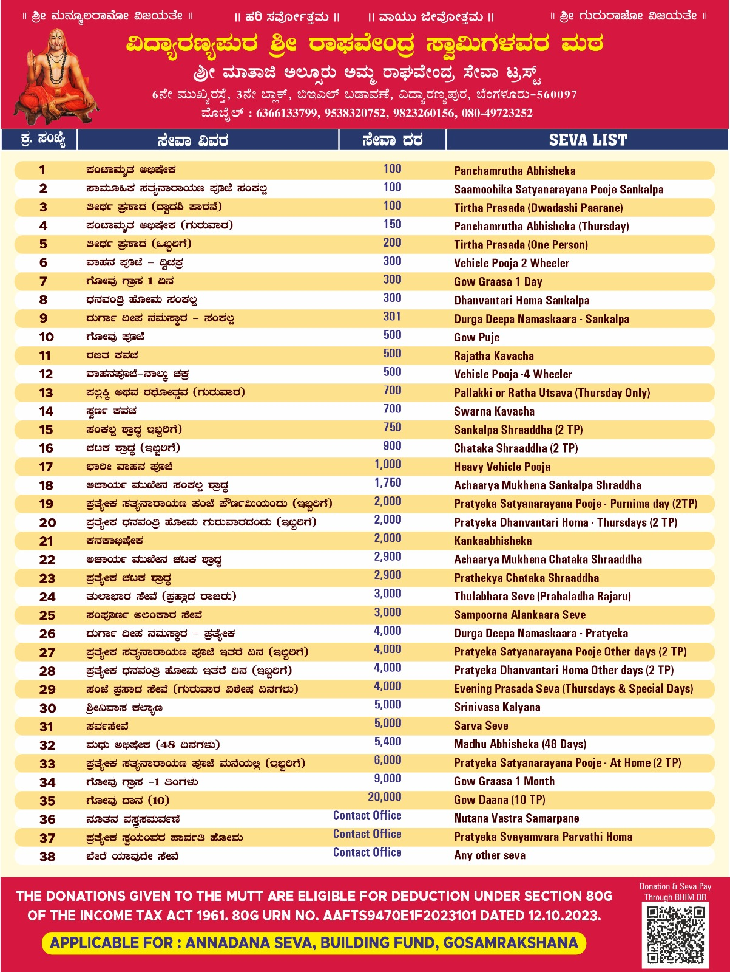
Sevas

Upcoming Events & Announcements
Stay connected with the sacred religious events at Vidyaranyapura Sri Raghavendra Swamy Mutt. Devotees are encouraged to participate in the upcoming poojas, aradhanas, and special occasions to receive the blessings of Guru Rayaru.

August 2025 Highlights
9th August 2025 (Saturday)
Rig & Yajur Veda – Nitya & Nuthana Upakarma
Vedic renewal rituals will be performed with full sankalpa and pooja. All yajurvedis and rigvedis are invited to participate and perform samarpana under Guru Rayaru's divine grace.
10th – 12th August 2025 (Sunday–Tuesday)
354th Sri Raghavendra Swamy Aradhana Mahotsava
A grand 3-day Mahotsava featuring:
- Panchamruta Abhisheka, Alankara Seva, Maha Mangalarathi
- Special homas, archana, pravachanas by scholars
- Bhajans, cultural events, and Annadana Seva daily
13th August 2025 (Wednesday)
Sri Sugnanendra Theertharu Aradhana
Special poojas will be conducted in reverence to the great yati in Rayaru's parampara.

Stay Updated
🔹 For regular updates and announcements, join our official WhatsApp group:
VRP Mutt Notice Board
Note for Web Developer:
  - Announcements could also be featured as a scrolling banner on the homepage for easy access.
  - Under ‘About Us,’ replace ‘Activities’ with ‘Guru Parampara’ and ‘Rare Privilege’ as given above
  - ‘Management’ to be replaced with ‘Parayana Samithi’ as given above
  - Remove ‘Souvenirs’ from ‘Gallery’
  - Photos, and Videos will be sent for other parts of ‘Gallery’ – Shortly
  - Add +91 6366133799 and 9538320752 to the ‘Phone:’ within ‘Contact’
  - We have a google page for our Mutt, which has received several positive reviews and has photos. Is it possible to link that URL into this website?
  - We need to have page / section for
    - Function Halls & Facilities
    - Gho Shala
    - Pilgrimage Tours (Yatras)
    - Vadhu Vara Division

